Aim: - Configuration of Hub, Switch and Router using Cisco Packet Tracer.

Software Required: -

Cisco Packet Tracer

Procedure and Outputs: -

Step 1: - Select a Hub type from the bottom left option.  
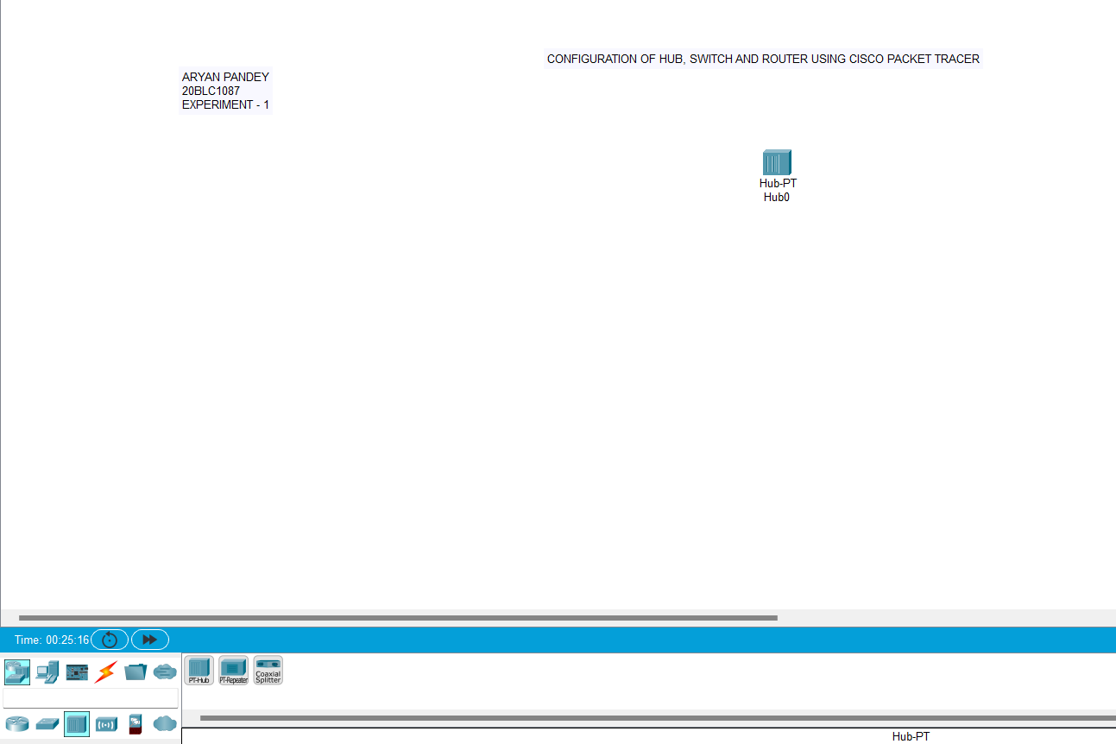

Step 2: Insert 6 PCs from the end devices option and connect the hub with the 6 PC’s using wire.  
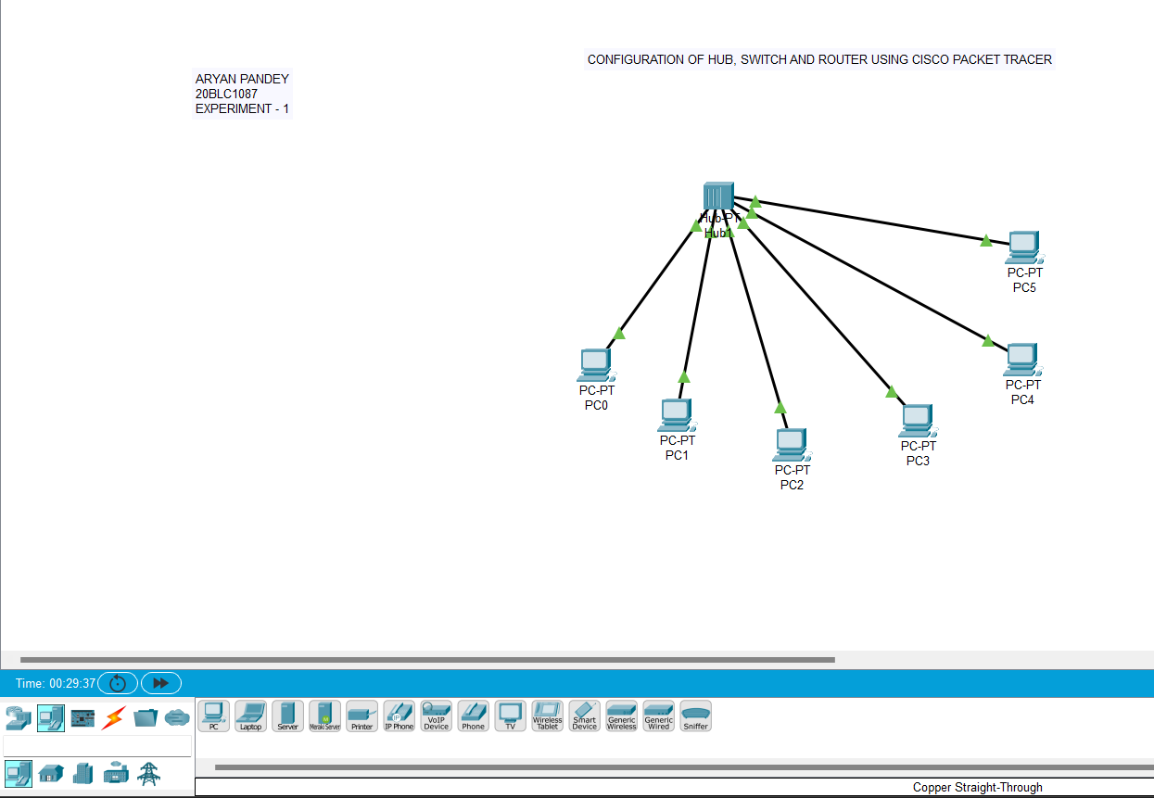

Step 3: - Click on the Hub, this will open its options and the click on the switch and this will on the Hub.  
 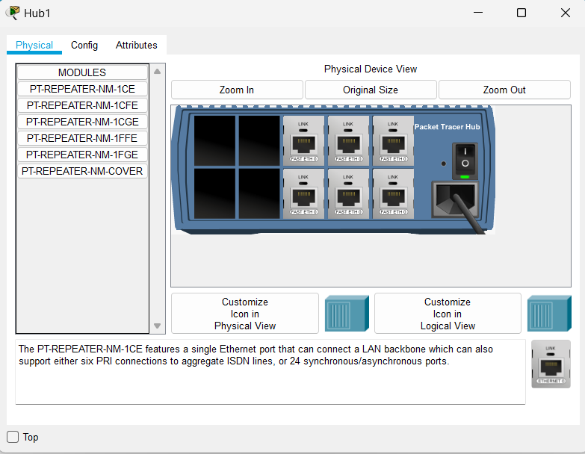

After switching on the map will change its color and arrows which indicates the hub is on.

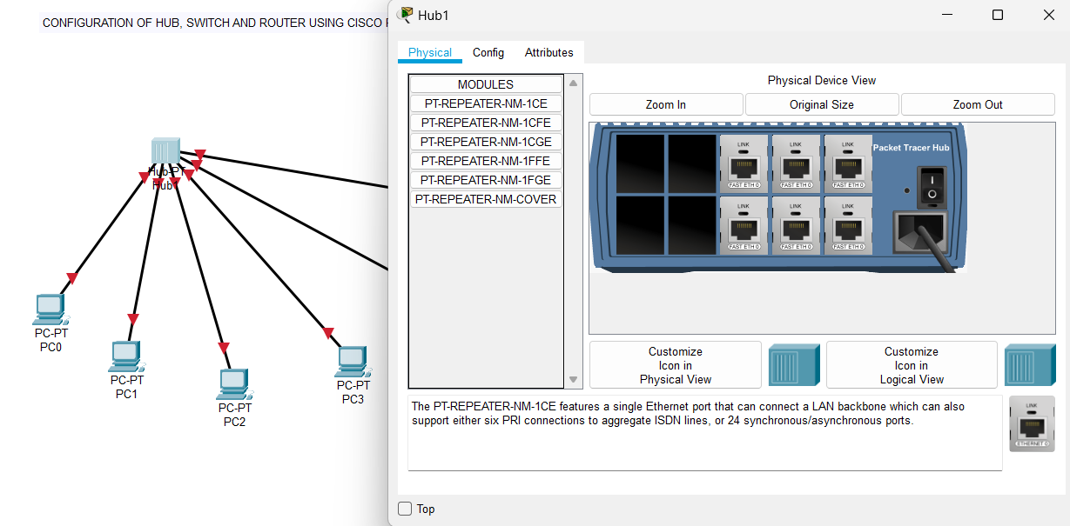

Step 5: -Click on any PC icon and then click on Desktop and then click on IP config, this will open a pop up.

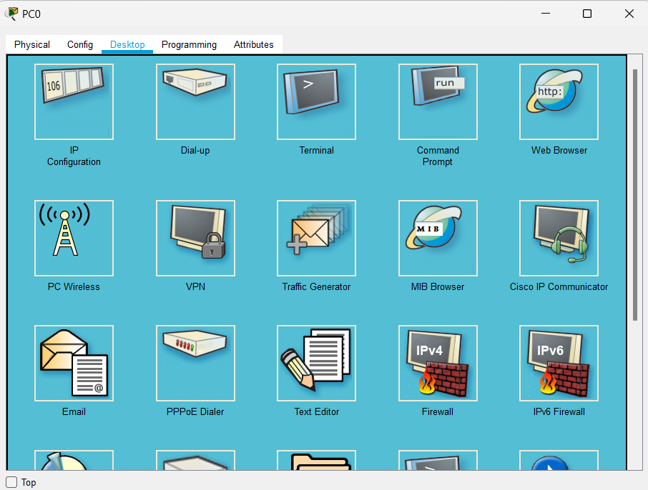

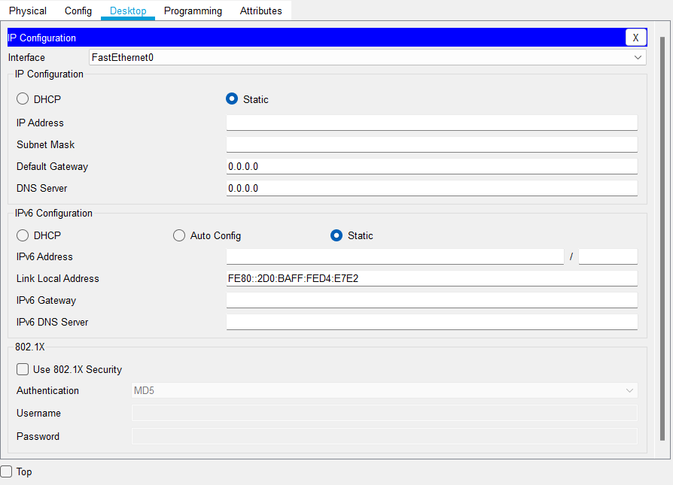

Step 6: - Type the IP address of the PC start from 10.10.10.1 for PC 0 and continue till the last PC till 10.10.10.6  
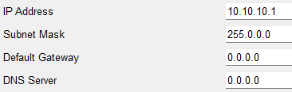

Step 7: - Give labels to the PC  
 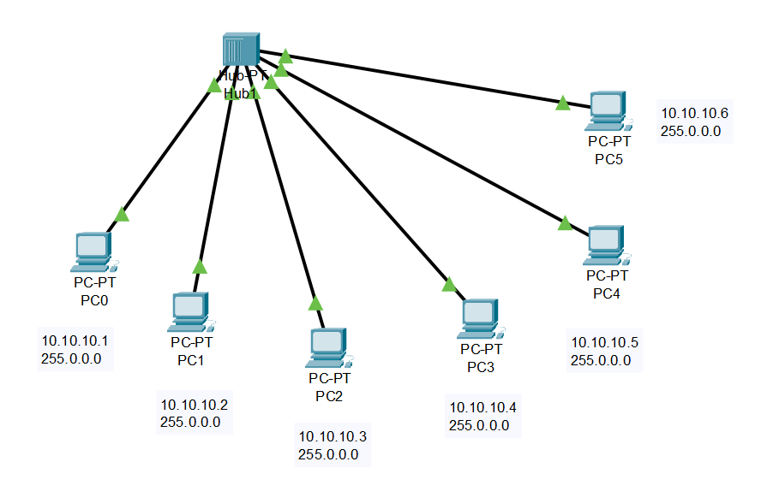

Step 8: - Again click on any PC and click on Desktop and open the command prompt from the options and write the commands for seeing the IP of PC 0 and checking the connection of the wires.  
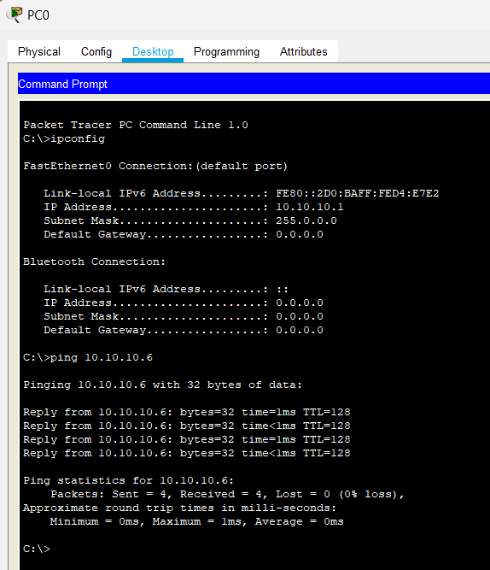

Step 9: - Click on Simulation and then click on the packet option and then select the starting PC and the ending PC then the scenario is formed and click on play button.

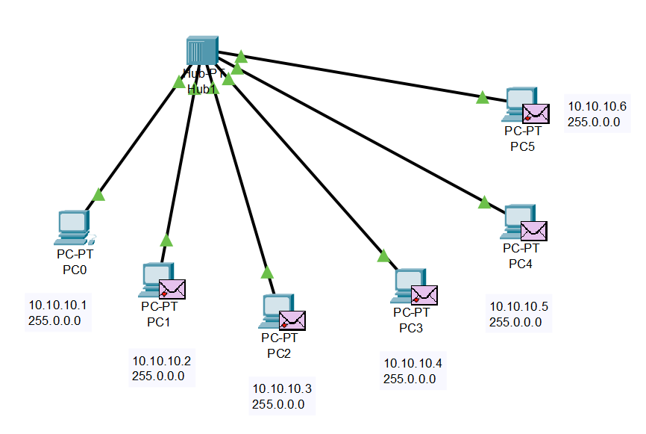

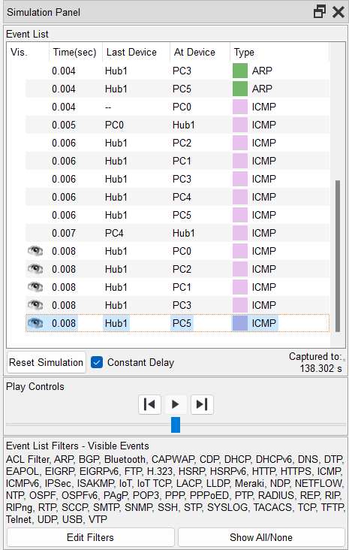

Step 10: - Repeat this whole process but use switch instead of hub.  
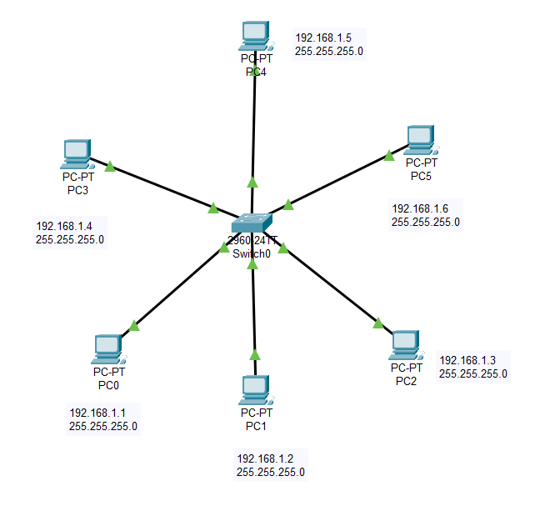

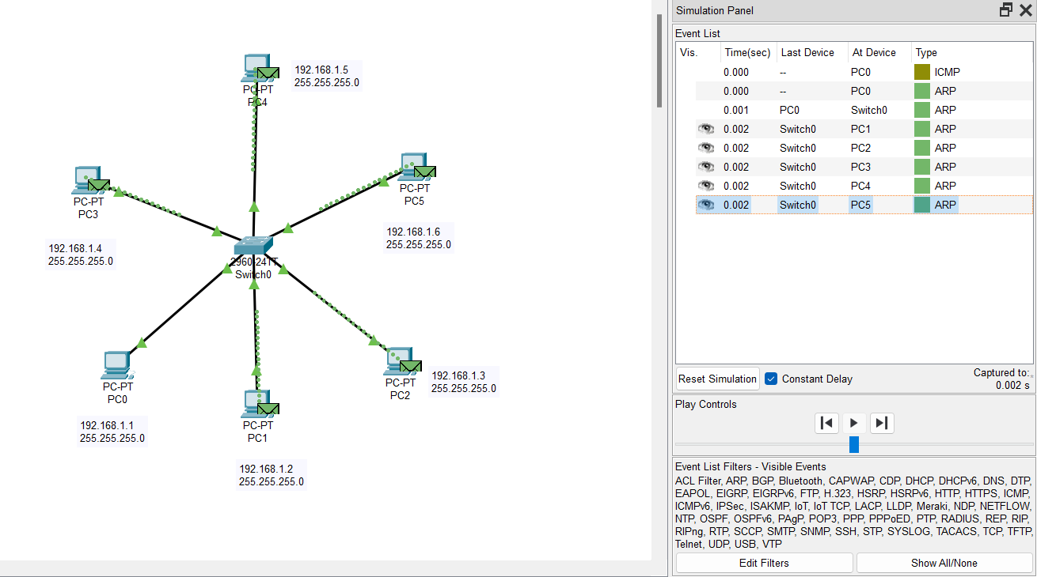

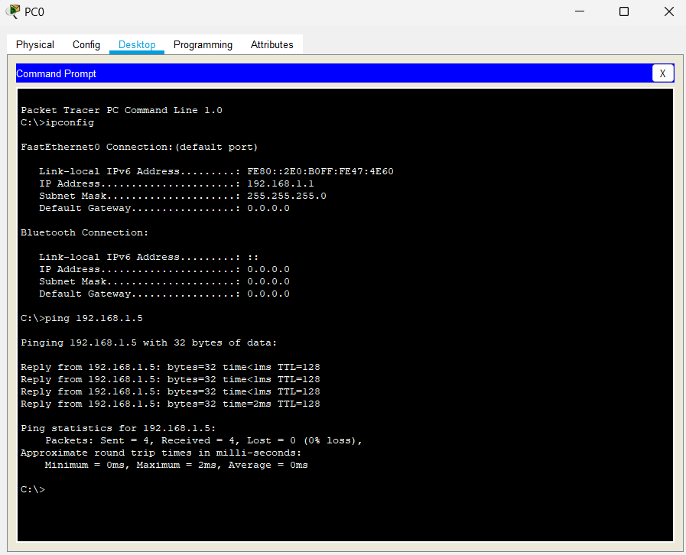

Step 11: - Now we use the router to connect to small networks of switch and we repeat the same process to make the small networks and configure it with IP.  
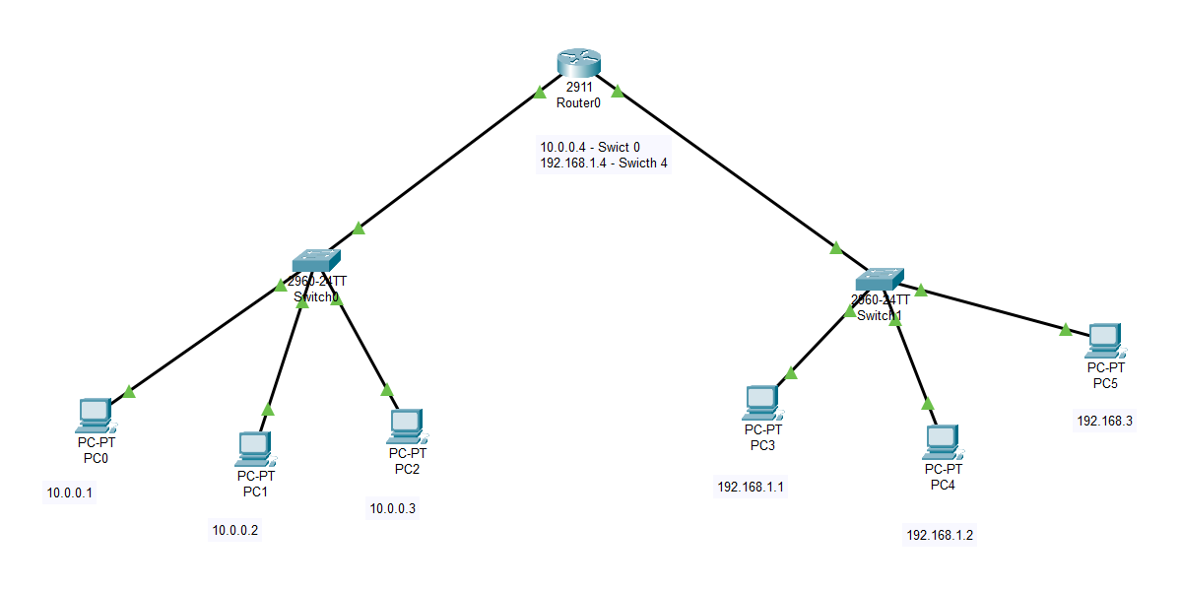

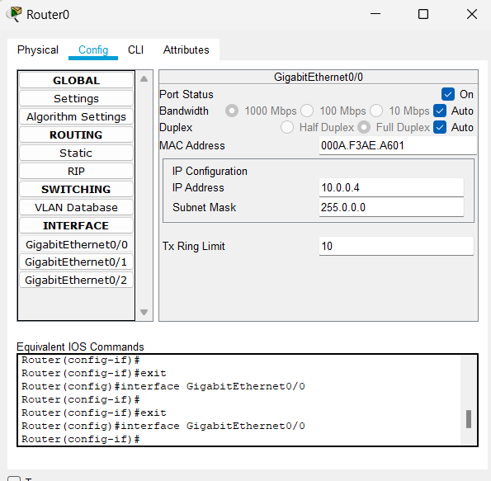

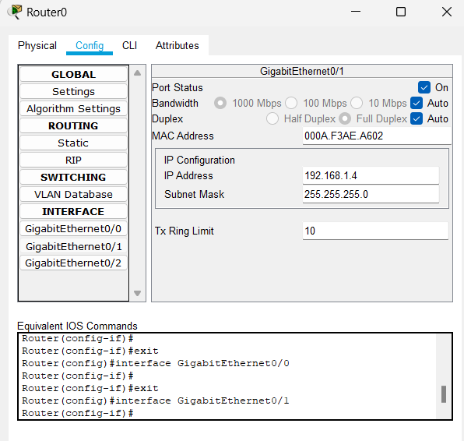

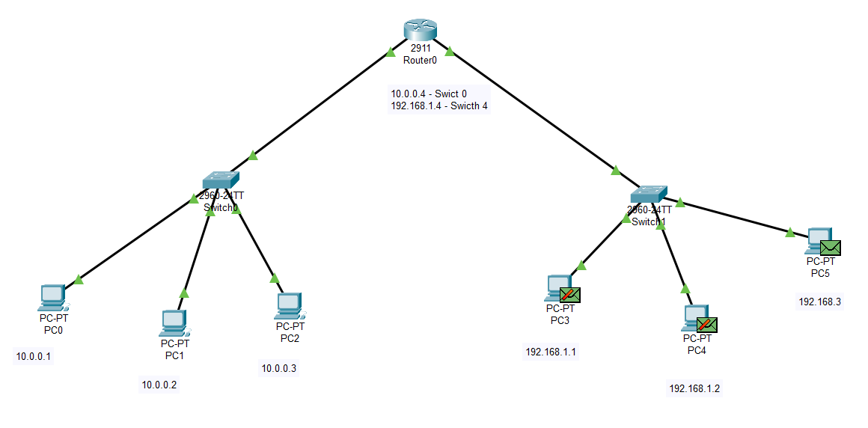

Step 12: - Now we use the switch and connect that the three hubs and then connect three PCs on each hub and configure it using IP.

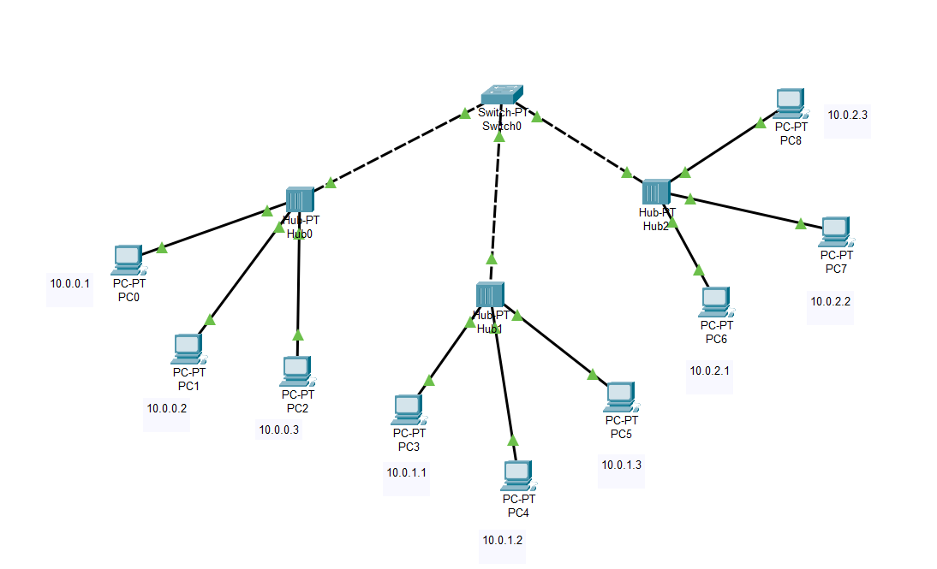

We repeat all the same steps and configure the PCs with the ip address from 10.0.0.1 to 10.0.2.3

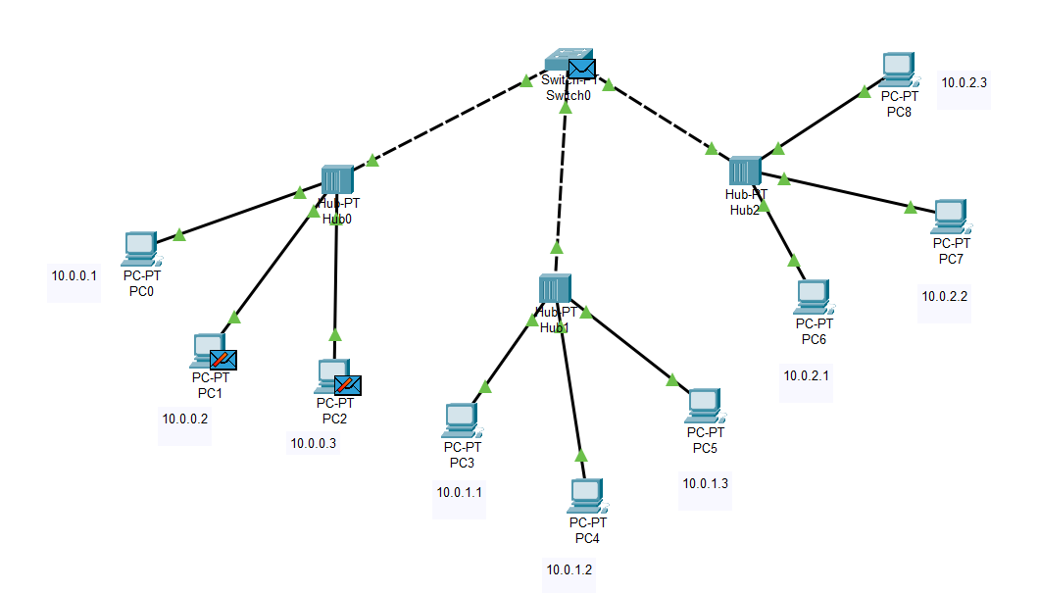

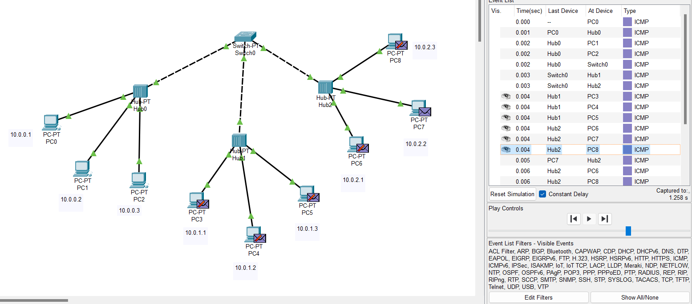

Step 13: - Now we use the router and connect the three switches and then connect three hubs on each switch and then we connect three PCs on each hub and configure it using IP.

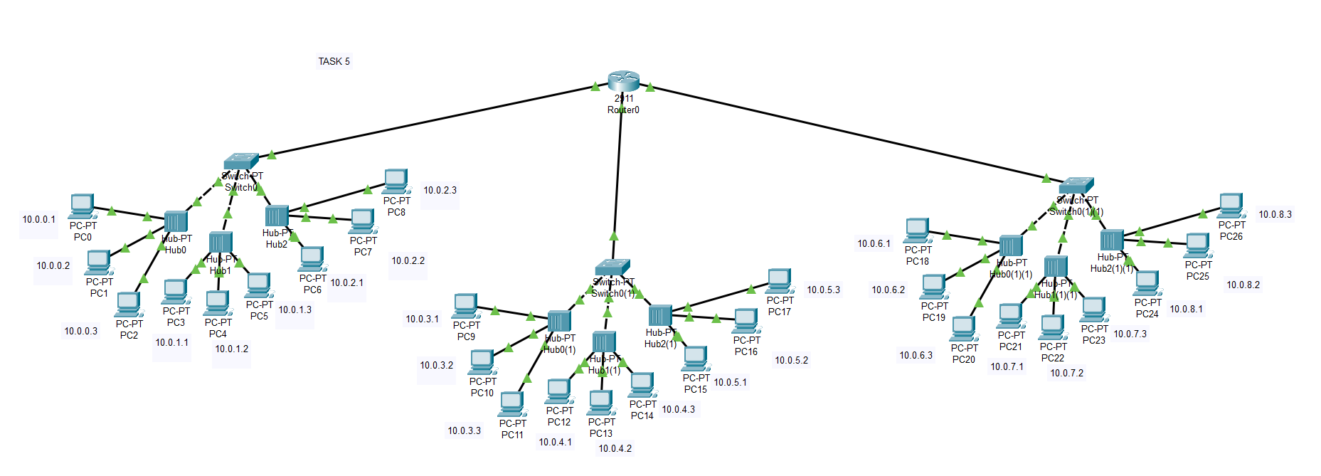

Verification Status: -

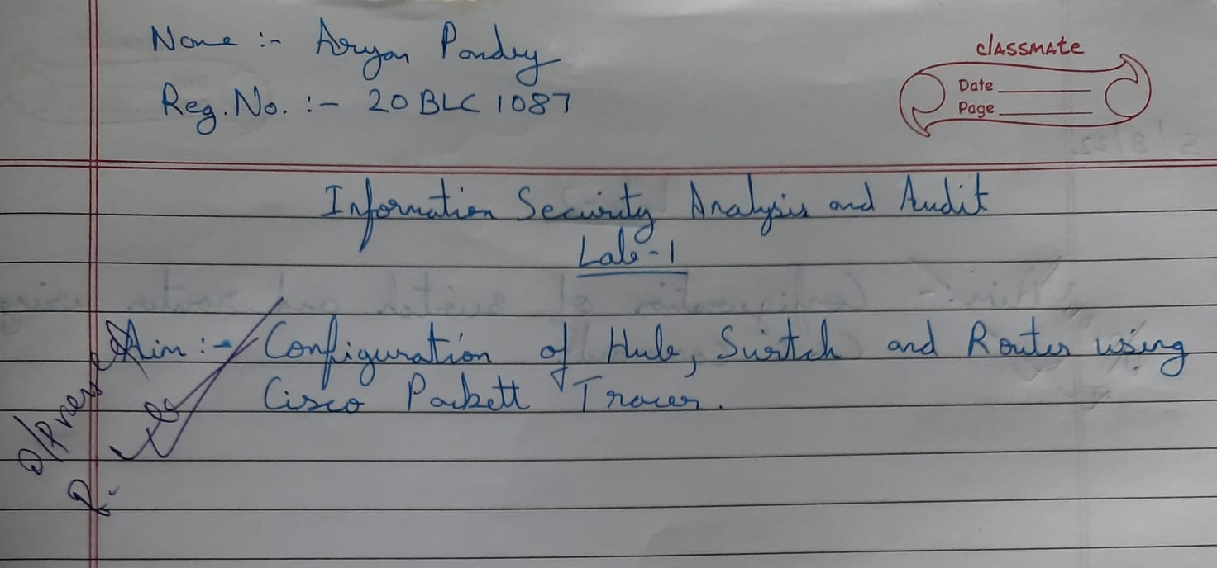

Result: -

Configuration of Hub, Switch and Router using Cisco Packet Tracer was successful and all the given task were completed.